Introduction

**FPT International School**

--- o0o ---

**PROJECT REPORT**

**CLOTHING STORE - LONGLOC**

Batch: T2108A

Semester: 2

Group: 2

Student2105008 Lê Như Việt Anh

Student2108007 Nguyễn Phương Nam

Student2104010 Lưu Hoàng Phú

Student2107020 Nguyễn Khắc Chiến

Student2107029 Mai Đức Hiền

Student2107016 Nguyễn Trường Thông

**Hanoi - 11/2017**

## Overview

**Requirement Specification:**

The Website include all of the below function:

1. The Home Page created making use of Sections with a suitable self-design Logo, the header section will show images an upcoming style collection.
2. The site must contain the links to navigate through various types of LED Lights.
3. Product can be categorized like (Dress, T-Shirt, Skirt, Jacket, etc.)
4. Specification and Pricing of clothing should be added along with the images.
5. The Product section for viewing different images.
6. Gallery, About us, Contact us link added. Address of the Company displayed using GeoLocation API (eg. GoogleMaps) and the email address which when clicked will invoke the local mail client from where they can send an email.
7. Client needs to register, login to enable the cart functionality
8. After checking the product details for size, colors, number of products, client can add product to the cart.
9. The cart will automatically calculate the price add up of products the client has choose
10. Press Order to receive a bill with all information including name of the client, phone number, address, note, product and finally price.
11. The admin will receive confirmation ID, send a confirmation Email to the client and the client can check the status of products.

### Implementation Environment

* Platform
* Windows 7, 10
* Language
* HTML 5
* CSS3
* Javascript
* JQuery
* Java
* Bootstrap 4
* Framework
* SpringBoot
* Application
* Dreamweaver CS6
* Chrome
* FireFox
* Methodology: Scrum

## User Stories

## 

# Follow chart

## GUI 1: login

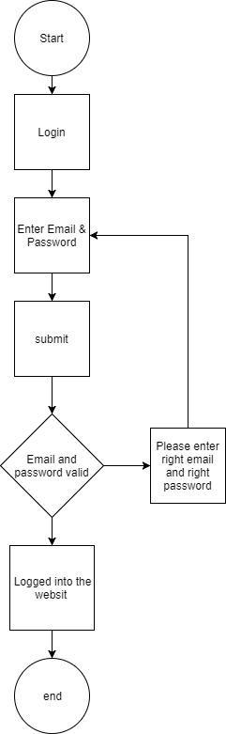

## GUI 2: Register

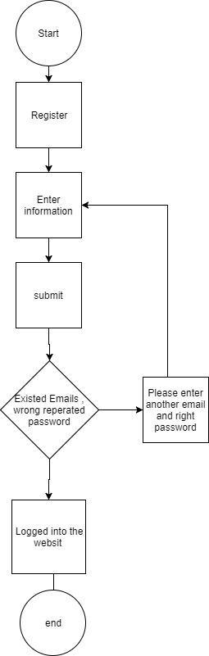

## GUI 3: search by names

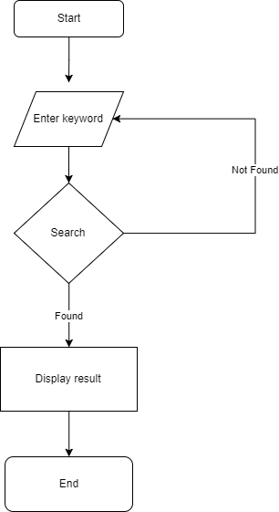

## GUI 4: View description of each product

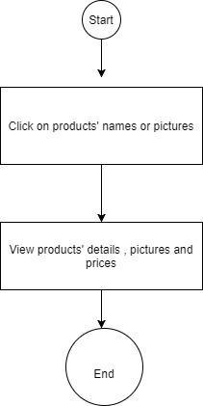

# UI\UX

## Homepage

## 

## Product details

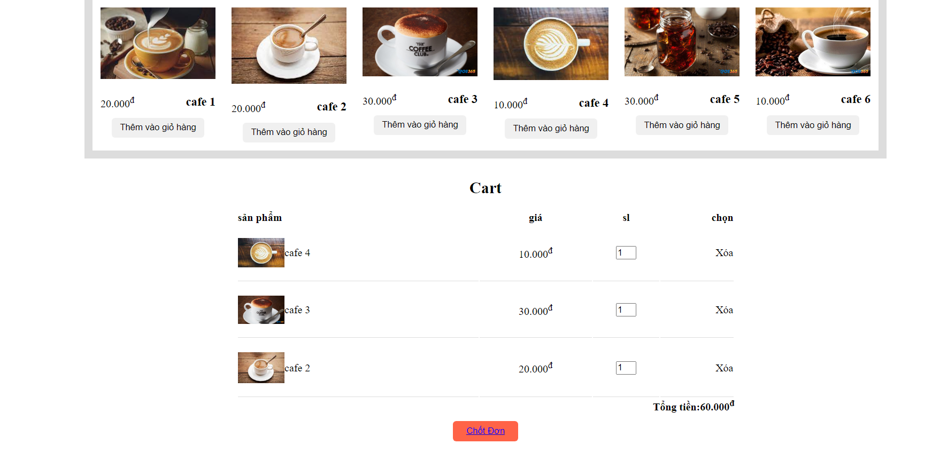

## Blog

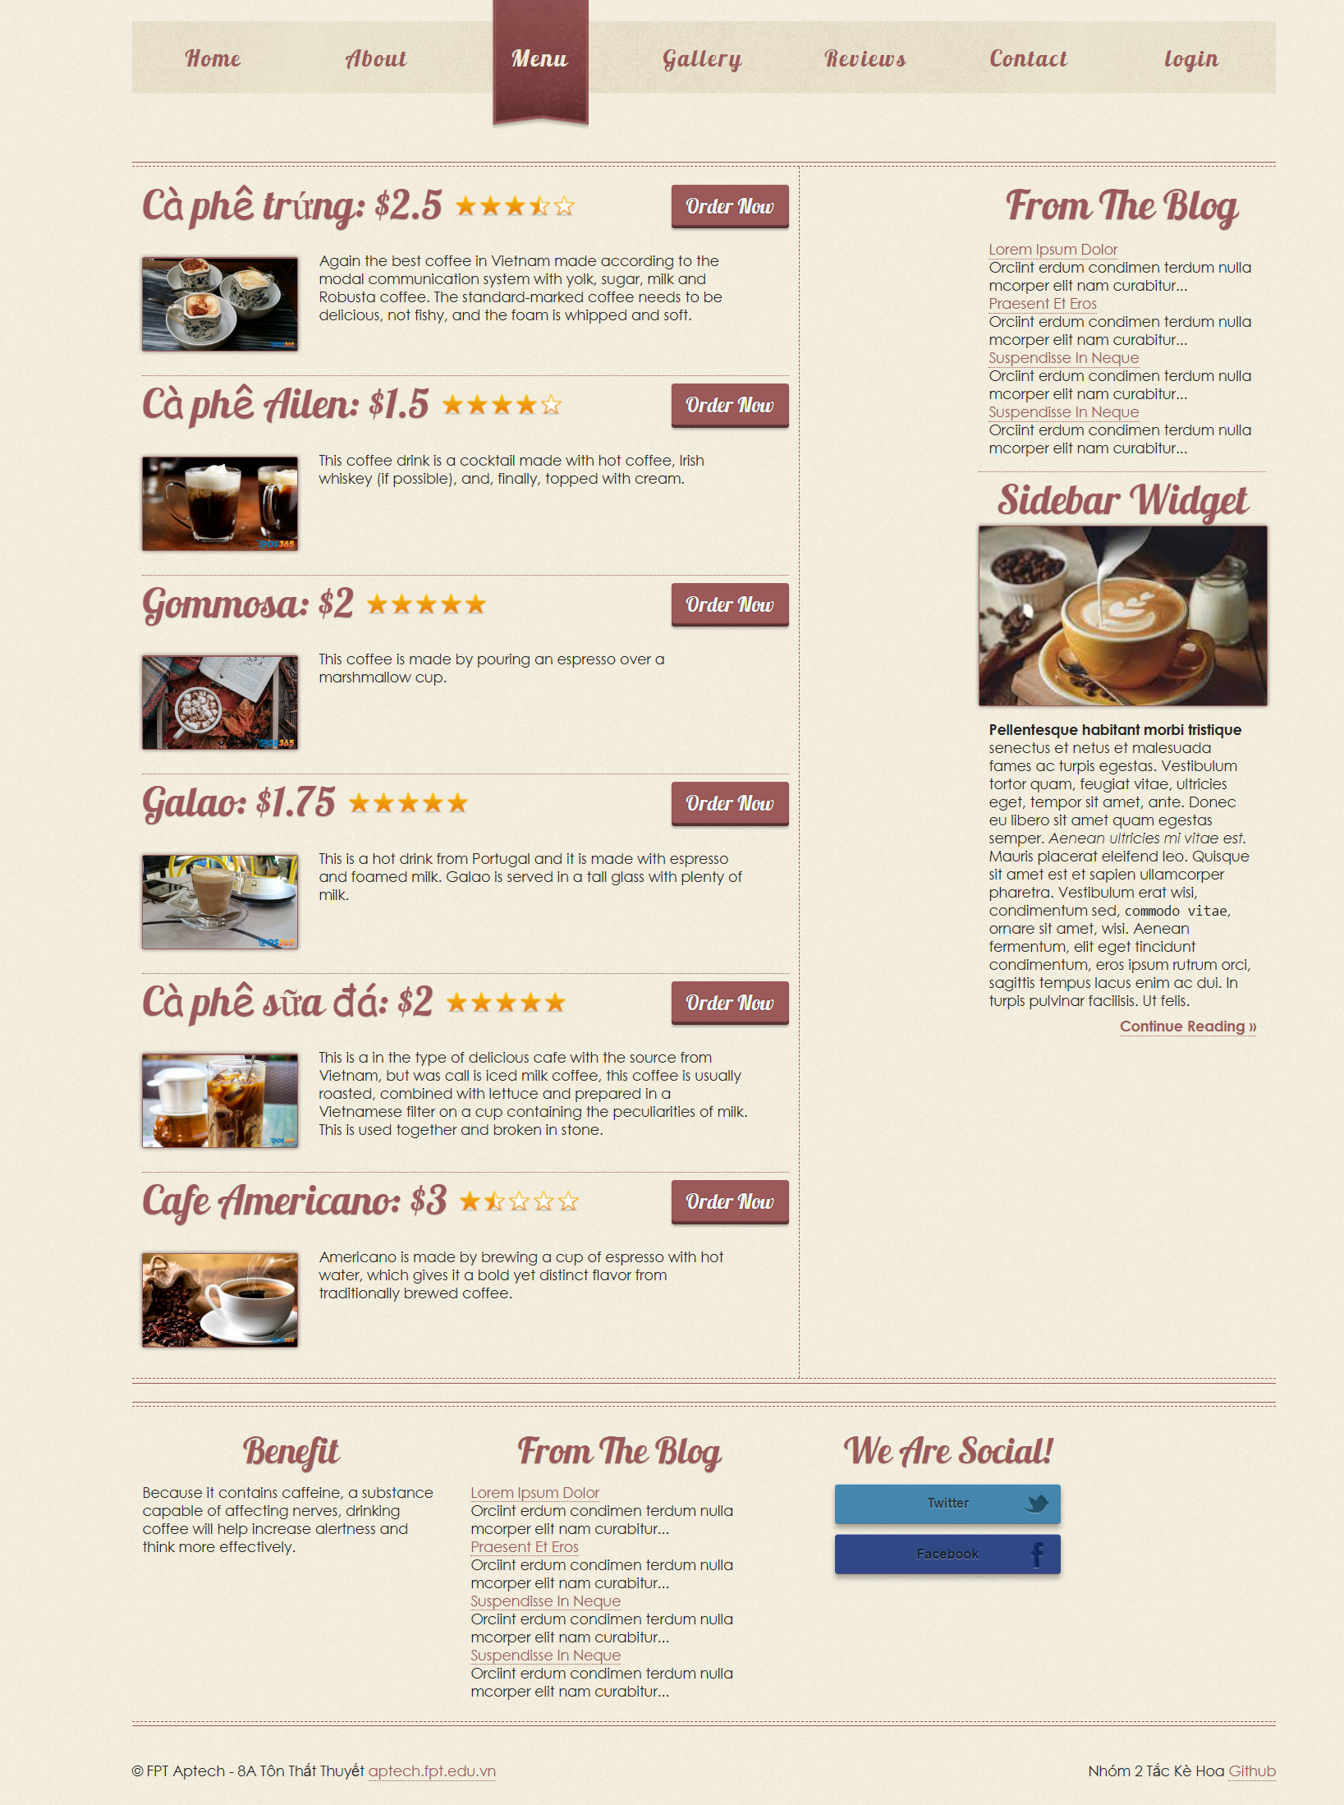

## Contact us

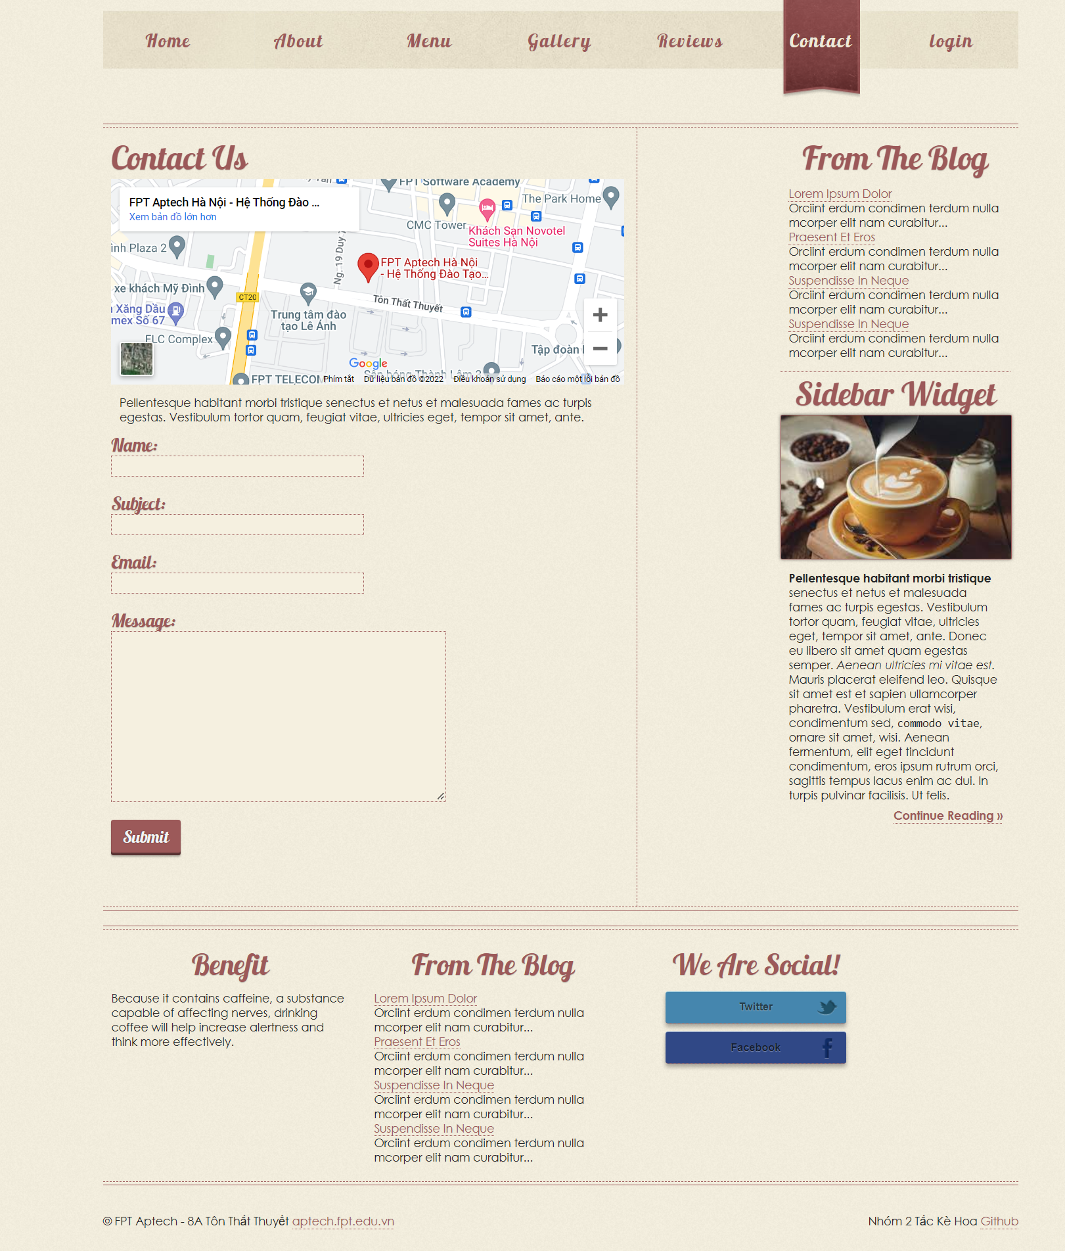

## Register

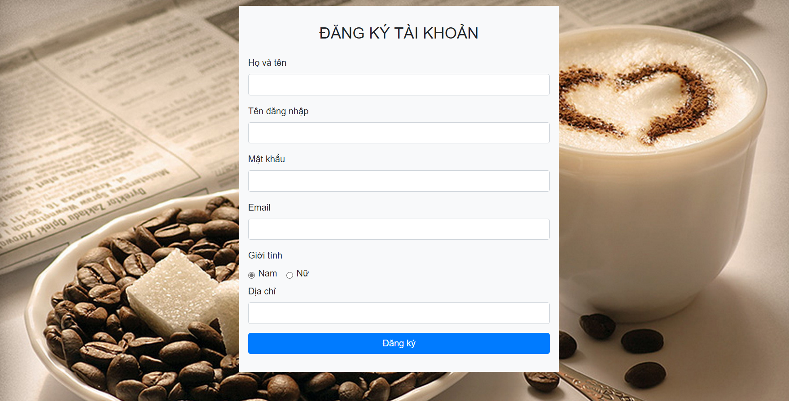

## Login

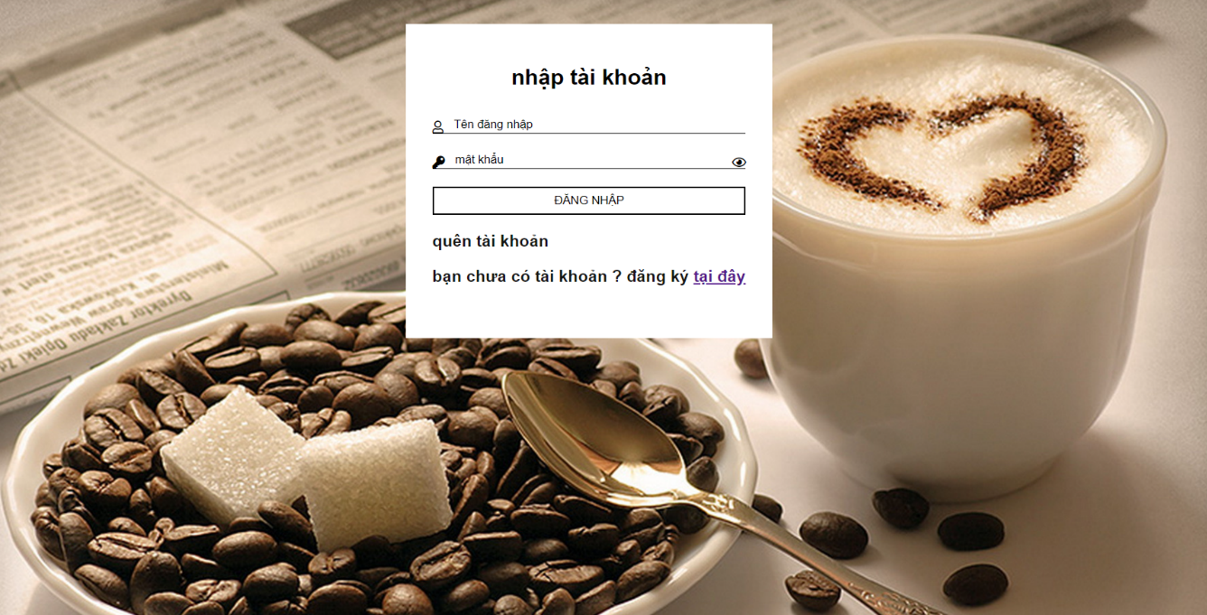

## Cart

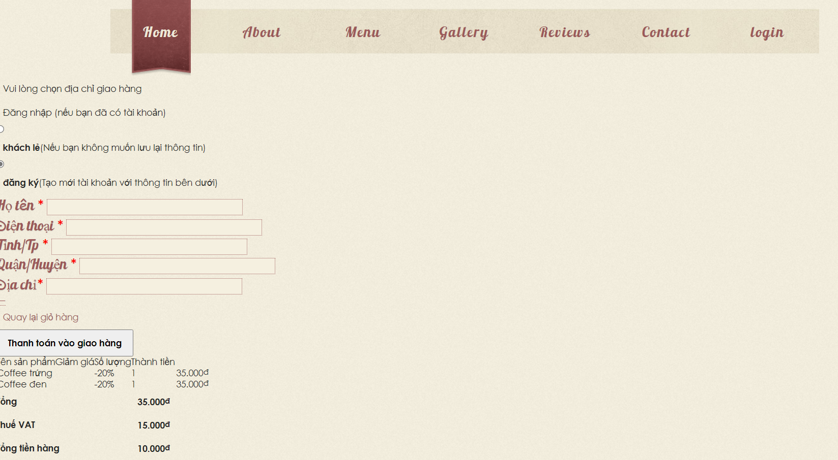

## Bill

## Checkout

## Confirmation Email

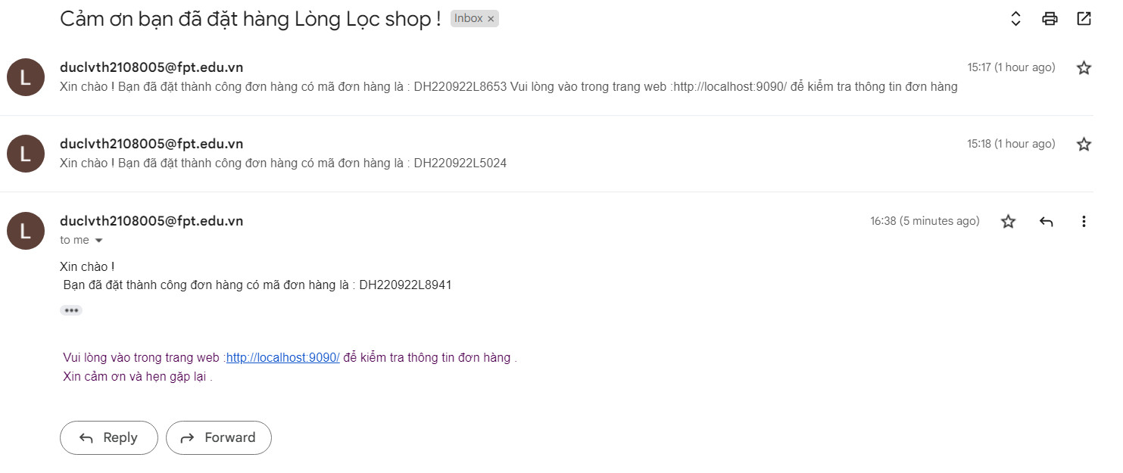

# Summary

The (x) means that person took part in the individual work

For instance: Trinh The Hiep did the Homepage and Header ,...

|  |  |  |  |  |  |  |  |
| --- | --- | --- | --- | --- | --- | --- | --- |
|  | Function | Lê Như Việt Anh | Nguyễn Phương Nam | Lưu Hoàng Phú | Nguyễn Khắc Chiến | Mai Đức Hiền | Nguyễn Trường Thông |
| 1. | Homepage |  |  | x |  |  |  |
| 2. | Header |  |  | x |  |  |  |
| 3. | Find resources: images and information of Clothing |  |  |  | x | x | x |
| 4. | Logo design |  |  | x |  |  |  |
| 5. | Login, Register |  | x |  |  |  |  |
| 6. | Login Configuration | x |  |  |  |  |  |
| 7. | Product Details |  |  |  |  | x |  |
| 8. | Blog |  | x |  |  |  | x |
| 9. | Admin |  |  | x |  |  |  |
| 10 | User Profile |  |  |  | x |  |  |
| 11 | Contact us |  |  |  |  | x |  |
| 12 | Cart |  | x |  |  |  |  |
| 13 | Bill | x | x |  |  |  |  |
| 14 | Checkout | x | x |  |  |  |  |
| 15 | Shipping Status |  |  | x |  |  |  |
| 16 | API | x |  |  |  |  |  |
| 17 | Confirmation Email | x |  |  |  |  |  |
| 18 | Frontend |  | x | x | x | x | x |
| 19 | Backend | xx | x | x |  |  |  |
| 20 | Merge Code | x | x | x | x | x | x |